仿生科技

期末報告-廣播稿

指導老師: [李旺龍](http://moodle.ncku.edu.tw/user/view.php?id=35472&course=47146)

Dermatobia hominis (Human Bot Fly)

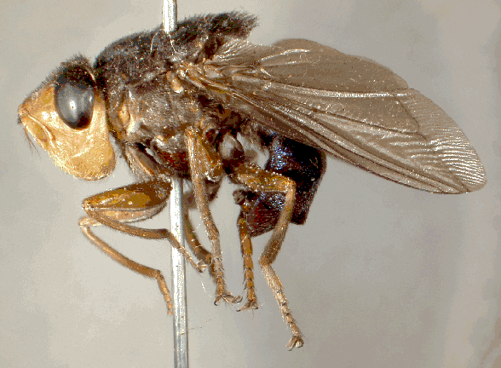

Photos courtesy of : http://www.sel.barc.usda.gov/diptera/oestrid/Dermatobia%20hominis%20Home.html

邱源凱(工業設計102)

F34985024

Botfly is the common name for several types of hairy insect flies whose larvae live as parasites within the bodies of mammals. There are all types of botflies that target horses, sheep, cattle, deer and even humans.

Dermatobia hominis also known as the human botfly, is a species of botfly (found only in Central and South America). By looking at its name, we can presume that it feeds on human’s muscle tissue. But how does the larva get to us?

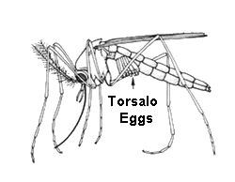To complete its life-cycle, a botfly has to find a way to get its eggs onto the skin of a host. But the adult botfly has a problem; it’s too big and conspicuous to drop the eggs of by itself. What is does is it uses a mosquito to deliver its eggs for it. Therefore, female human botfly overcome this problem by catching smaller fly such as mosquitoes and gluing eggs to the underside of the captive's body. The captive is then released unharmed, while carrying the botfly’s eggs until it lands on a warm-blooded host. Body heat melts the glue and from immediately triggers rapid hatching of the eggs. The tiny maggots then quickly burrow into the skin and begin development as internal parasites.

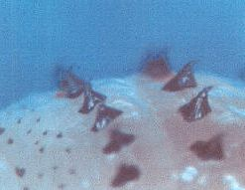  
The larvae now eat their way into the skin of the person, and begin feeding on muscle tissue. Little tiny black spines hold them in place. Those are there so that if the host tries to pull it out, it’s going to lodge into place. Great way to make sure it doesn’t get pull out easily by the host. A hole is left in the skin so the larvae can breathe.   
  
A boil-like lesion develops at the site of infestation. After about 6 weeks undisturbed, the larvae have grown fat while dining on human flesh; they eat their way out and drop to the ground, where they pupate. Adult botflies emerge from the pupas in about four weeks, and the cycle starts all over again.   
  
People who have had a botfly larvae infestation in their flesh report that they could feel the maggots moving under their skin. Removing the maggots is difficult, as they are hooked to the flesh. Sometimes they can be squeezed out, but often surgery is necessary. Doctors actually advise that victims not try to remove the larvae on their own, as the larvae may burst; leaving maggot parts inside your skin that could lead to serious infection. One way to extract the botfly is to cover the air holes, starving the maggots out of oxygen. When the cover is removed, the maggot surfaces, and can be extracted safely.  
  
Usually the wound heals quickly, with no side-effects other than a little scar. Occasionally there may be tiny infection. However, if the site where the maggots are is easily damaged, quick removal is necessary to prevent other complications.

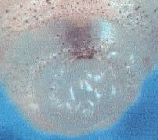

This is a photo of its mouth.

Photo courtesy by Stephen Higgs, Ph.D. with the Department of Pathology at UTMB.

How Does Botfly got to do with Bionic Technology?

 

Black Spines on its back and be design as special hooks that can use for fishing or catching animals. Because the original of the design was to be able to hook on to human flesh without getting pulled out easily. So if we are able to incorporate this design to our fishing industry or into a product that serves the same purpose, this way we can increase of technology usage. The way the spines are distributed is also a good way to start.



We also talked about how Botfly’s eggs are being carried by a carrier. This way of dispersing eggs and their offspring is a good way of us to learn from. The reason is because outer space technology advancement is increasing and if we are able to drop humans off from space shuttle to different planets maybe this can change our way of transportation.